**JS Advanced Retake Exam**

**Problem 1. Service**

**Environment Specifics**

Please, be aware that every JS environment may **behave differently** when executing code. Certain things that work in the browser are not supported in **Node.js**, which is the environment used by **Judge**.

The following actions are **NOT** supported:

* **.forEach()** with **NodeList** (returned by **querySelector()** and **querySelectorAll()**)
* **.forEach()** with **HTMLCollection** (returned by **getElementsByClassName()** and **element.children**)
* Using the **spread-operator** (**...**) to convert a **NodeList** into an array
* **append()** in Judge (use only **appendChild()**)
* **replaceWith()** in Judge
* **replaceAll()** in Judge
* **closest()** in Judge
* **replaceChildren()**
* Always turn the collection into a **JS array** (forEach, forOf, et.)

If you want to perform these operations, you may use **Array.from()** to first convert the collection into an array.

**Use the provided skeleton to solve this problem.**

**Note**: You **can't** and you have no permission to **change** directly the given HTML code (index.html file).

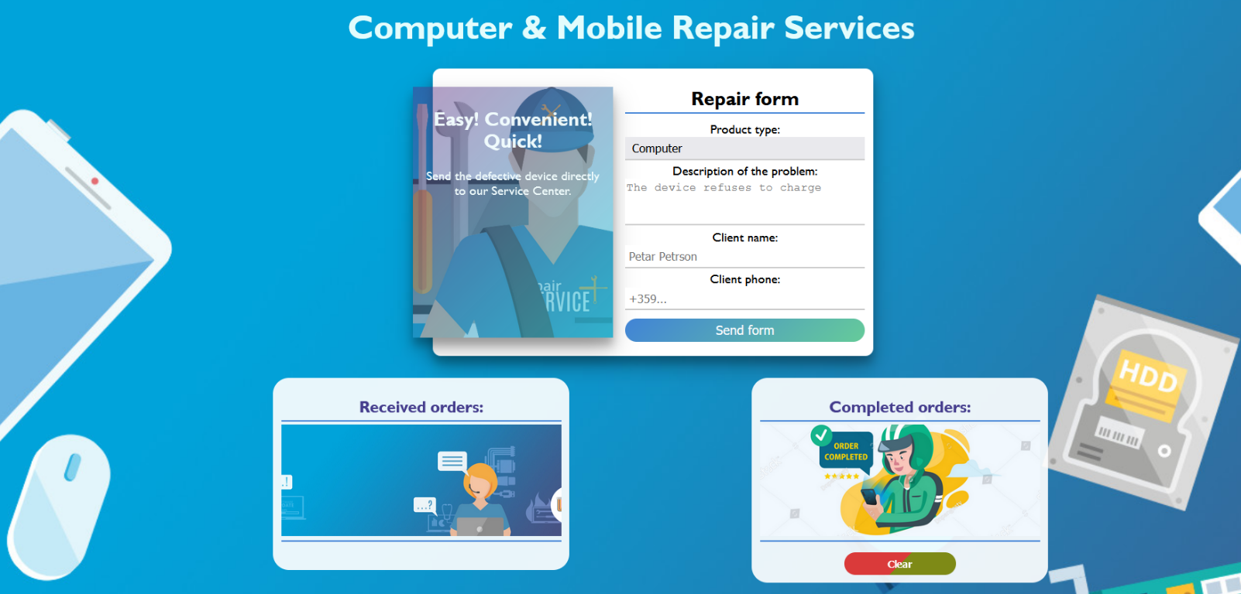

**Your Task**

**Write the missing JavaScript code** to make the **Service** work as expected:

* All fields **(description, client name, and client phone)** are **filled with the correct input**
  + **Description, client name,** and **client phone** are **non**-**empty** **strings**. If any of them are empty, the program should not do anything.
  + **Note** that the possible values for the Product type are two - **Phone** and **Computer**.To see which **drop-down menu** option is **selected**, read its parent's properties: **value.**

1. 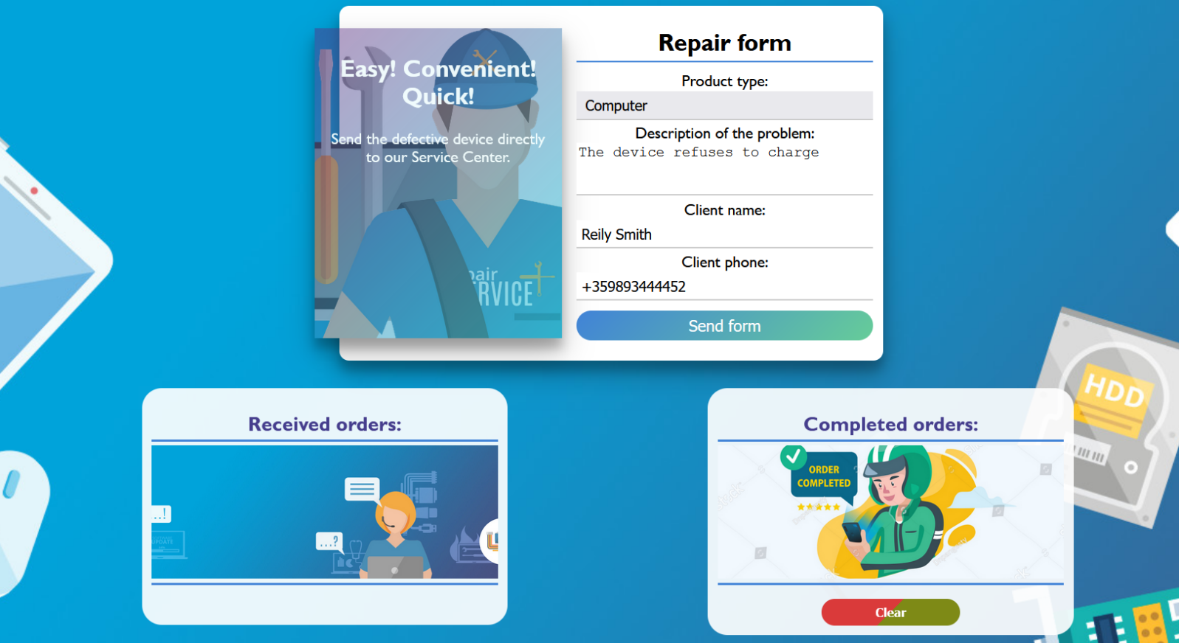**Getting the information from the repair form**

* When you click the **["Send form"]** button, the information from the input fields must be added to the **section** with the **id** **"received-orders"** and **then clear input fields**.
* The HTML structure looks like this:

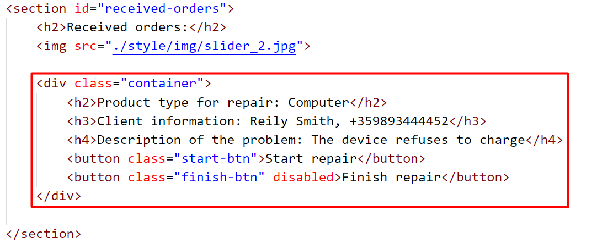

**Note:** When an order is successfully added, the button **["Finish repair"]** must be **disabled**, as the order cannot be completed if it has not started (Once the button is **disabled**, its color will turn gray).

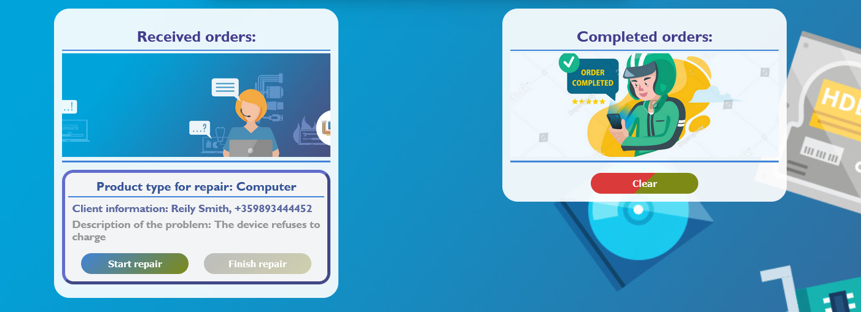

* When the **["Start repair"]** button is clicked, repair on the device begins. Since the process has already started, the worker will not be allowed to restart it, so the **["Start repair"]** button must be **disabled.** (Once the button is **disabled**, its color will turn gray).
* 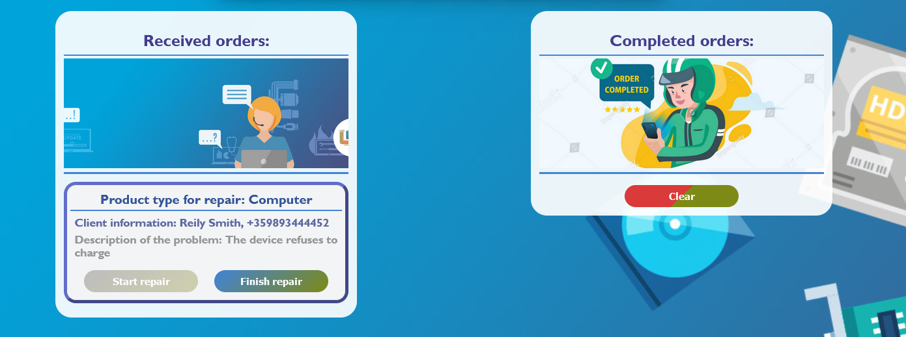Button **["Finish repair"]** must become activated.
* 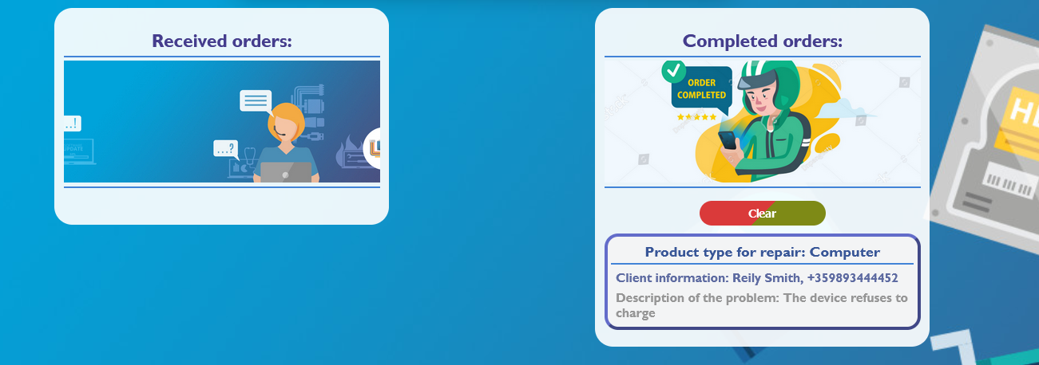When the **["Finish repair"]** button is clicked, repair on the deviceis complete. Therefore, you need to move the current device in the **section** with the **id** **"completed-orders"**.
* The HTML structure looks like this:

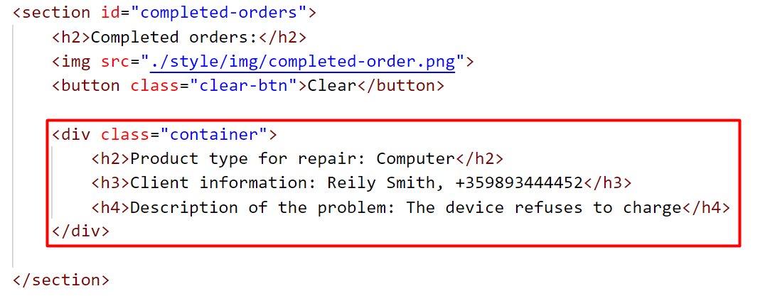

* 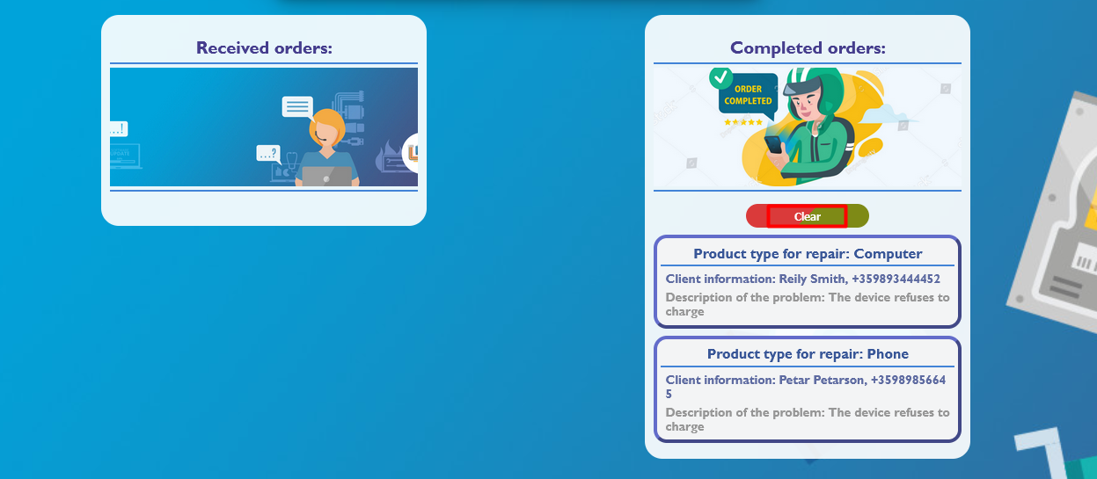When you click the **["Clear"]** button, you must **remove** all added **div** elements with **class** **"container"** from the section **Completed orders**.
* 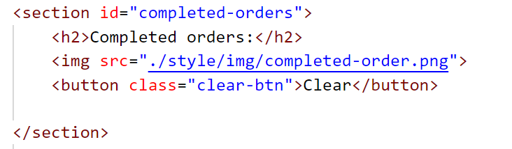The HTML structure looks like this:

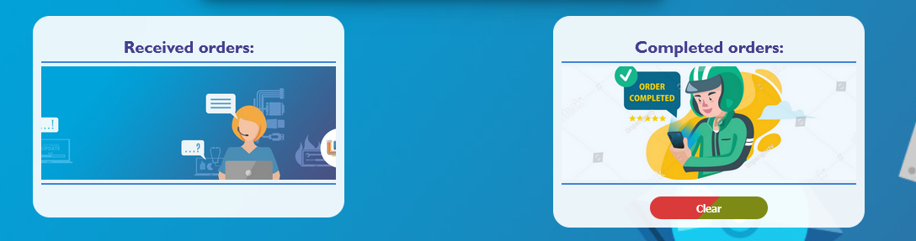

**Submission**

Submit only your **solve()** function.

*GOOD LUCK… ☺*